Project: SkillSphere – AI-Driven Career Readiness and Personalized Learning Recommendation Platform
Git & Docker Technical Project Report

Submitted in the partial fulfilment for the Course of
CSA1012 – SOFTWARE ENGINEERING
to the award of the degree of
BACHELOR OF TECHNOLOGY
IN
COMPUTER SCIENCE(AI)
Submitted by
R.Jalaja (192525365)
Under the Supervision of
DR ANITADAVAMANI K
SIMATS ENGINEERING
Saveetha Institute of Medical and Technical Sciences
Chennai-602105
Aug -2026
TABLE OF CONTENTS
1. Introduction
2. Project Overview
3. Problem Statement
4. Objectives
5. System Features and Modules
6. Technology Stack
7. Project Folder Structure
8. Application Architecture
9. Backend Implementation
10. Frontend Implementation
11. Git Version Control
12. GitHub Repository
13. Docker Containerization
14. Docker Compose Deployment
15. Application Execution and Testing
16. Results and Output
17. Advantages
18. Limitations
19. Future Scope
20. Conclusion
21. References

1. INTRODUCTION
SkillSphere is an AI-driven career readiness platform designed to help students understand their current skills, identify skill gaps, and receive career-oriented recommendations. The project provides a web dashboard connected to a Node.js REST API. The backend organizes student information, skill-gap logic, recommendation logic, and reference catalog data.
The project is organized as two main services: a backend service and a frontend service. The backend is implemented with Node.js and Express, while the frontend is a static web dashboard served using Nginx. Docker is used to package both services into containers, and Docker Compose is used to run the services together.
Git is used for version control and GitHub is used as the remote repository. This makes the project easier to track, maintain, share, and reproduce on another system.
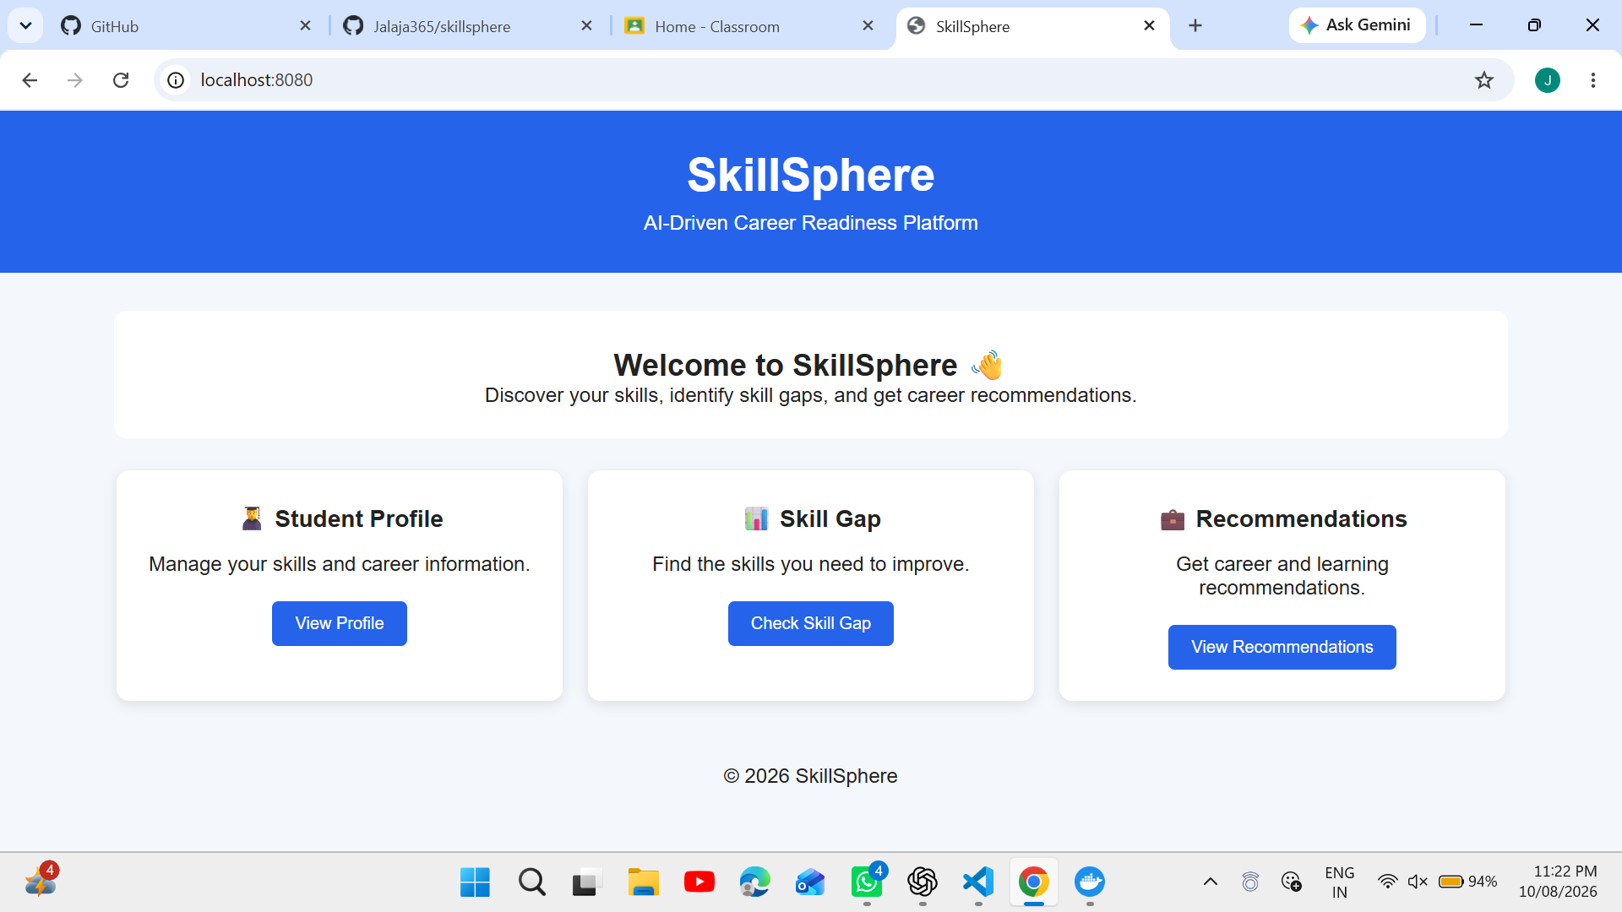.

2. PROJECT OVERVIEW
The SkillSphere platform follows a simple client–server approach. A user interacts with the frontend dashboard through a web browser. The frontend communicates with the backend REST API for student-related operations, skill-gap analysis, and recommendations.

Main Components
- Frontend – Static HTML, CSS and JavaScript dashboard.
- Backend – Node.js REST API using Express.
- Controllers – Student, skill-gap, and recommendation business logic.
- Model/Data Layer – In-memory student store.
- Catalog – Static role and skill reference data.
- Docker – Separate containers for frontend and backend.
- Docker Compose – Starts and manages both services together.
- Git/GitHub – Version control and remote source-code management.

3. PROBLEM STATEMENT
Students often know the career role they are interested in but may not clearly understand which skills they already possess and which skills they need to improve. Manual career guidance can also be difficult to personalize for every student.
SkillSphere addresses this problem by providing a structured platform where student skill information can be maintained, skill gaps can be identified, and career-oriented recommendations can be generated from reference role and skill data.

4. OBJECTIVES
- Create a simple web-based career readiness dashboard.
- Maintain student information and skill-related data.
- Identify gaps between current skills and target-role skills.
- Provide recommendations based on identified gaps and reference data.
- Organize backend code into controllers, routes, models, and data modules.
- Containerize the frontend and backend using Docker.
- Use Docker Compose to run both services together.
- Track the project using Git and publish it to GitHub.

5. SYSTEM FEATURES AND MODULES

5.1 Student Management Module
The student management module handles student-related information required by the application. The backend includes studentController.js and studentStore.js to organize this functionality.

5.2 Skill Gap Analysis Module
The skill gap module compares the student's available skills with the skills required for a target career role. The result helps the student understand which areas need improvement.

5.3 Recommendation Module
The recommendation module uses student and skill information to provide career-oriented recommendations. The recommendationController.js file contains the related backend logic.

5.4 Career Skill Catalog
The catalog.js file contains static reference information about career roles and related skills. This data supports skill-gap and recommendation operations.

5.5 Web Dashboard
The frontend provides the user-facing dashboard. HTML defines the structure, CSS provides presentation, and JavaScript handles browser-side interaction and API communication.

6. TECHNOLOGY STACK
Technology | Purpose | Project Use
HTML | Web structure | Frontend interface
CSS | Presentation | Dashboard styling
JavaScript | Client-side logic | Frontend interaction/API calls
Node.js | JavaScript runtime | Backend execution
Express | Web framework | REST API
Nginx | Web server | Frontend container serving
Docker | Containerization | Packages services
Docker Compose | Service orchestration | Runs frontend + backend
Git | Version control | Tracks source changes
GitHub | Remote repository | Stores project online

7. PROJECT FOLDER STRUCTURE
The project is organized into separate frontend and backend services:
skillsphere/
├── backend/
│ ├── src/
│ │ ├── controllers/
│ │ │ ├── studentController.js
│ │ │ ├── skillGapController.js
│ │ │ └── recommendationController.js
│ │ ├── models/
│ │ │ └── studentStore.js
│ │ ├── routes/
│ │ │ └── api.js
│ │ ├── data/
│ │ │ └── catalog.js
│ │ ├── router.js
│ │ └── server.js
│ ├── package.json
│ ├── Dockerfile
│ └── .dockerignore
├── frontend/
│ ├── src/
│ │ ├── index.html
│ │ ├── styles.css
│ │ └── app.js
│ ├── Dockerfile
│ ├── nginx.conf
│ └── docker-entrypoint.sh
├── docs/
├── docker-compose.yml
├── .gitignore
└── README.md

8. APPLICATION ARCHITECTURE
SkillSphere uses a two-service architecture. The browser communicates with the frontend container. The frontend is served through Nginx and communicates with the Node.js backend API. Docker Compose provides the environment needed to run both services together.
User Browser
│
▼
Frontend Container
(Nginx + HTML/CSS/JS)
│
│ REST API requests
▼
Backend Container
(Node.js + Express)
│
├── Controllers
├── Routes
├── Student Store
└── Skill/Career Catalog
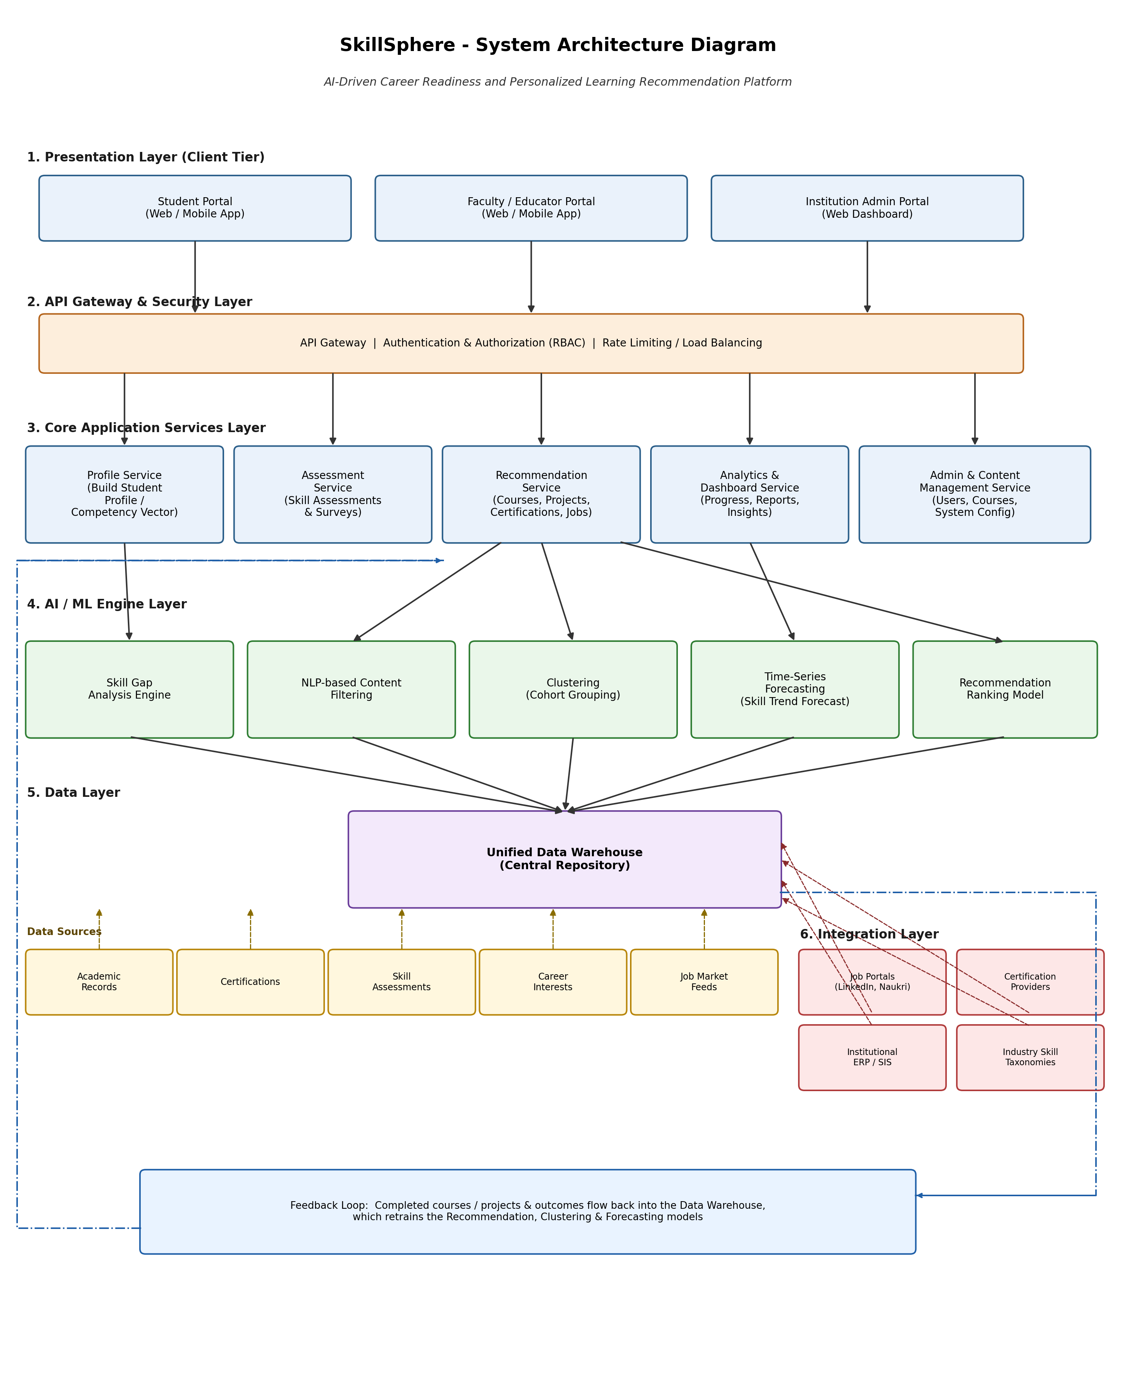

9. BACKEND IMPLEMENTATION
The backend is implemented as a Node.js REST API. Express is used to create the web server and handle API requests. The project uses a modular structure so that each business area can be maintained separately.

9.1 Server
server.js is the application entry point. It starts the backend server and connects the API routing with the application.

9.2 Controllers
- studentController.js – handles student-related operations.
- skillGapController.js – handles skill-gap analysis operations.
- recommendationController.js – handles recommendation-related operations.

9.3 Routes
api.js connects API routes to the relevant controllers. This keeps URL routing separate from business logic.

9.4 Model/Data Layer
studentStore.js acts as an in-memory data layer for student information. catalog.js provides static career-role and skill reference data.

9.5 Express Dependency
Express was installed in the backend using npm. Because the system's PowerShell execution policy blocked npm.ps1, npm.cmd was used successfully for package commands.

10. FRONTEND IMPLEMENTATION
The frontend is a static web dashboard consisting of index.html, styles.css and app.js. It is served through Nginx inside a Docker container.
- index.html – defines the dashboard structure and content.
- styles.css – controls layout, typography, spacing, and visual presentation.
- app.js – provides browser-side functionality and API communication.
- nginx.conf – configures Nginx for serving the frontend.
- docker-entrypoint.sh – supports runtime configuration such as API URL injection.

11. GIT VERSION CONTROL
Git was used to create a local repository and track the SkillSphere source code. The main branch was used for the project. The repository was initialized, project files were staged, committed, and later synchronized with GitHub.

11.1 Repository Initialization
Command: git init
This creates the hidden .git directory and starts version control for the project.

11.2 Main Branch Configuration
The project uses main as the primary branch.

11.3 Staging and Commit
Commands: git add .
git commit -m "chore: add initial SkillSphere project structure"
The commit creates a permanent snapshot of the project so changes can be tracked and restored later.

11.4 Verification
Command: git status
The final Git status showed “On branch main” and “nothing to commit, working tree clean”, confirming that the local working tree was clean.
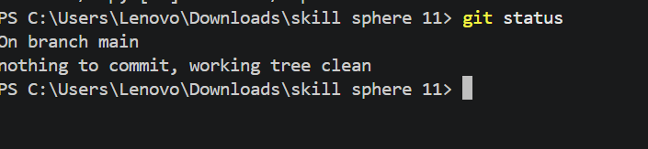

12. GITHUB REPOSITORY
The local Git repository was connected to the GitHub repository owned by Jalaja365. The remote repository is named skillsphere. The project was synchronized with GitHub using the main branch.
Remote repository: https://github.com/Jalaja365/skillsphere
GitHub provides a remote backup of the project and makes the source code available for collaboration, submission, and version tracking.
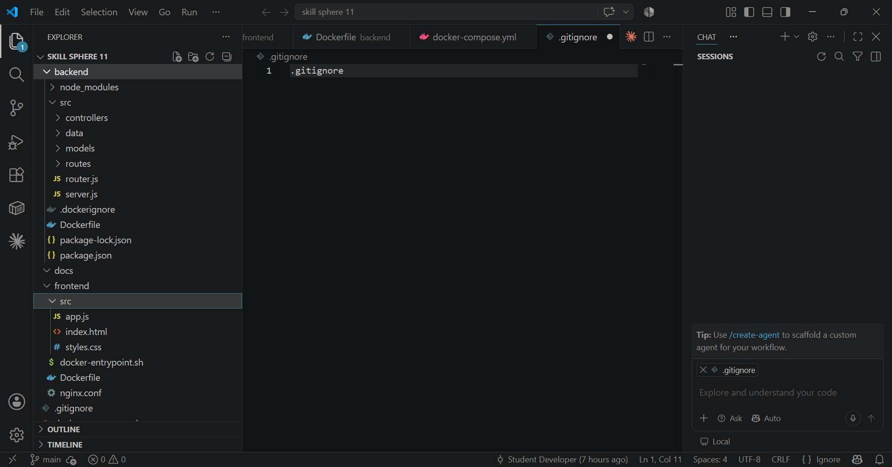

13. DOCKER CONTAINERIZATION
Docker was used to package the SkillSphere backend and frontend as separate containerized services. Containerization reduces dependency problems and makes the application easier to run consistently.

13.1 Backend Dockerfile
The backend Dockerfile defines the environment required to run the Node.js API, installs project dependencies, copies the application files, and starts the backend service.

13.2 Frontend Dockerfile
The frontend Dockerfile packages the static dashboard and configures it to run through Nginx.

13.3 Docker Compose
docker-compose.yml defines both services and allows them to be started together with one command.

13.4 Docker Commands Used
docker --version
docker compose version
docker info
docker compose build
docker compose up -d
docker compose ps

14. DOCKER COMPOSE DEPLOYMENT
Docker Compose was used to start both services at the same time. After Docker Desktop was running correctly, the command below started the SkillSphere containers:
docker compose up -d
The successful startup output showed two containers being started: skillsphere11-backend-1 and skillsphere11-frontend-1. This confirms that the Compose configuration was accepted and both services could be launched.
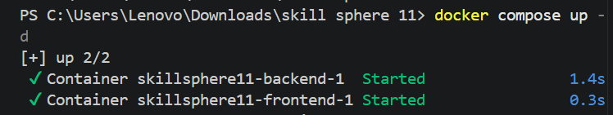

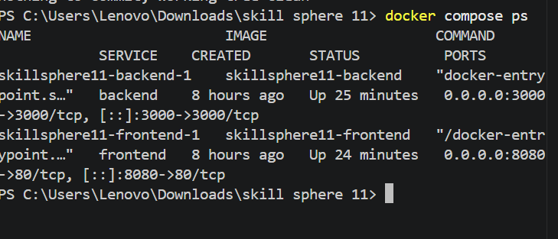

15. APPLICATION EXECUTION AND TESTING
After the containers were started, the frontend application was accessed through the browser using the localhost port exposed by Docker Compose.
Application URL: http://localhost:8080
The successful opening of the SkillSphere web application in the browser confirms that the frontend container was reachable from the host system. The backend service runs separately and provides the API functionality.

16. RESULTS AND OUTPUT
The implementation achieved the main technical goals of the project. The SkillSphere source code is organized into backend and frontend services, version controlled with Git, stored in GitHub, and deployed using Docker Compose.

Observed Results
- The Node.js backend dependencies were installed successfully.
- The backend and frontend Docker images were created successfully.
- Docker Compose successfully started the two SkillSphere services.
- The containers were accessible through the configured ports.
- The frontend application opened successfully in a web browser.
- Git reported a clean working tree after the project was committed.
- The project was pushed to the GitHub repository Jalaja365/skillsphere.


17. ADVANTAGES
- Modular backend structure makes maintenance easier.
- Separate frontend and backend containers provide clear service boundaries.
- Docker provides a consistent runtime environment.
- Docker Compose simplifies multi-service deployment.
- Git maintains a history of project changes.
- GitHub provides remote storage and collaboration support.
- The architecture can be extended with a database and real AI/ML recommendation engine later.

18. LIMITATIONS
- The current student data layer is in-memory rather than a permanent database.
- The career catalog is based on static reference data.
- Advanced AI recommendation functionality can be expanded in future versions.
- Authentication and role-based access can be added for a production deployment.
- Production deployment would require stronger security, monitoring, logging, and persistent storage.

19. FUTURE SCOPE
- Integrate MySQL, PostgreSQL, or MongoDB for persistent student and skill data.
- Add student login and secure authentication.
- Add a richer AI/ML-based career recommendation engine.
- Include learning-resource recommendations for each identified skill gap.
- Add progress tracking, dashboards, and reports.
- Deploy the containers to a cloud platform.
- Add CI/CD automation using GitHub Actions.
- Add automated tests and API documentation.
- Provide administrator and student roles.

20. CONCLUSION
SkillSphere successfully demonstrates the development and deployment of a small web-based career readiness platform using a modern software engineering workflow. The project separates the frontend dashboard from the Node.js REST backend and organizes the backend into controllers, routes, models, and reference data.
Git and GitHub were used for version control and remote repository management. Docker and Docker Compose were used to containerize and run the frontend and backend services together. The final application was successfully opened in a browser through localhost:8080, confirming the successful integration of the project components.
Overall, the project provides a strong foundation for extending SkillSphere into a complete career readiness platform with persistent storage, authentication, advanced recommendations, learning resources, analytics, and cloud deployment.

21. REFERENCES
Node.js Documentation – https://nodejs.org/
Express.js Documentation – https://expressjs.com/
Docker Documentation – https://docs.docker.com/
Docker Compose Documentation – https://docs.docker.com/compose/
Git Documentation – https://git-scm.com/doc
GitHub Documentation – https://docs.github.com/
Nginx Documentation – https://nginx.org/en/docs/

SCREENSHOT CHECKLIST FOR FINAL REPORT
The report has placeholders so that your actual screenshots can be inserted without changing the written content.
- 1. SkillSphere application home/dashboard – browser screenshot.
- 2. Architecture diagram – if you have one.
- 3. Git status showing 'nothing to commit, working tree clean'.
- 4. GitHub skillsphere repository page showing project files.
- 5. docker compose up -d showing backend and frontend Started.
- 6. docker compose ps showing both services Up and port mappings.
- 7. SkillSphere working at http://localhost:8080.
- 8. Optional: screenshot of dashboard/features inside SkillSphere.

